**SECTION A (60 Marks)**

Answer only **three** questions from this section.

1. Write electronic configuration of copper (I) ion and chloride ion. (02 marks)
2. Explain the reaction between aqueous solutions of copper (II) ions and iodide ions. (03½ marks)
3. Describe the process of extracting copper from copper pyrites. (08½ marks)
4. Excess concentrated ammonia solution was added to a copper ore and the solution made up to the **1 litre** mark with distilled water. The resultant solution was shaken with an organic solvent and left to settle. **50.0cm3** of arganic layer needed **25.0cm3** of **0.05M** hydrochloric acid for neutralization reaction. **25.0cm3** of the aqueous layer was neutralized by **40.0cm3** of **0.5M** hydrochloric acid. Calculate the concentration of copper (II) ions in **mol/dm3**. [Partition coefficient between water and organic solvent, KD = **25.0**] (06 marks)
5. Water and phenylamine are immiscible and the saturated vapour pressures of pure liquids at **98ᵒC** are **9.43 x 104N/m2** and **7.07 x 103N/m2** respectively. The boiling point of pure water is **100ᵒC** and that of pure phenylamine is **184ᵒC**.Describe what happens when a mixture of the two liquids is agitated and heated to boil. [Normal atmospheric pressure is **1.01325 x 105N/m2**] (05 marks)
6. What is meant by the term **steam distillation**? (02 marks)
7. Assuming that phenylamine and water are truly immiscible, describe how phenylamine can be separated from inorganic compounds by steam distillation. Draw a diagram for the process involved. (08 marks)
8. Give one advantage of using steam distillation above. (01 mark)
9. State one other application of steam distillation. (01 mark)
10. An organic compound, **T** was steam distilled at **1** atmospheric pressure and a temperature of **97ᵒC**.The distillate contained **4.29g** of organic compound, **T** and **1.10g** of water. Calculate the relative molecular mass of organic compound, **T**. Vapour pressures of water and organic compound, **T** at the given temperature are **0.39atm** and **0.61atm** respectively. (03 marks)

1. Write equations to show how bromoethane can be converted to propanone [propan-2-one]. (04 marks)
2. Describe:
3. The reaction of hot sodium hydroxide solution with bromoethane.Outline a mechanism for the reaction that occurs. (04 marks)
4. Draw an energy profile for the reaction in b (i) above. (03½ marks)
5. Describe an experiment that can be carried out to test for presence of bromide, Br- ions in aqueous solution. (02½ marks)
6. A bromoalkane, R with molecular formula [C4H9Br] when reacted with concentrated hydrochloric acid in presence of anhydrous zinc chloride formed two layers of liquids immediately.
7. Write the structural formula and IUPAC names of bromoalkane, R. (02 marks)
8. Write an equation and outline a mechanism for the reaction between bromoalkane, R and sodium methoxide in methanol. (04 marks)
9. Describe an experiment that can be carried out to determine enthalpy of solution of sodium hydroxide. (09 marks)
10. State what is observed and write equation(s) for the reaction(s) that occur(s) when aqueous sodium hydroxide is added to each of the following solutions dropwise until in excess.
11. Copper (II) nitrate. (02½ marks)
12. Aluminium sulphate. (04½ marks)
13. You are given standard electrode potentials for half-cell reactions at **25ᵒC.**

Half-cell reactions: Eθ (Volts)

Na(s) Na+(aq) + e- +2.71

Al3+(aq) + 3e- Al(s) -1.66

1. Write cell notation for the cell reaction formed when the half-cells are connected. (01 mark)
2. Write equation for the reaction at each electrode. (03 marks)

**SECTION B (40 Marks)**

Answer only **two** questions from this section.

1. Discuss the reactivity of group (IV) elements of the periodic table. (10 marks)
2. Explain why carbontetrachoride molecule is non-polar yet the bonds in carbontetrachoride are polar. (04 marks)
3. The solubility of lead (II) chloride at **20ᵒC** is **9.9g/dm3**.Calculate the solubility product for lead (II) chloride at **20ᵒC**. (06 marks)
4. Write equations to show how the following compounds can be synthesized.
5. Phenylpropyne from phenylethanol. (06 marks)
6. Aminomethane from ethene. (05½ marks)
7. Phenylmethanol to benzene. (03 marks)
8. 2-phenylethanol from 1-bromophenylethane. (03 marks)
9. Name the pair of functional groups that can be distinguished using iron (III) chloride. State what would be observed if each member of the pair of functional groups is separately treated with the reagent. (02½ marks)

1. What is meant by the term ideal solution? (03 marks)
2. The boiling points of pure water and hydrogen chloride are **100ᵒC** and **-85ᵒC** respectively. A mixture of water and hydrogen chloride boils at **108.5ᵒC** when the mixture is **20%** hydrochloric acid.
3. Sketch a boiling point-composition diagram for water and hydrochloric acid. (03½ marks)
4. Describe what happens when a solution containing less than **20.2%** hydrochloric acid is fractionally distilled. (04 marks)
5. Explain why the mixture shows this deviation from ideal behavior. (03 marks)
6. The vapour pressure of ethanol at **20ᵒC** is **43.6mmHg** while that of benzene at the same temperature is **75.2mmHg**. The mole fraction of benzene is **0.09** for a mixture of benzene and ethanol at **20ᵒC**. Calculate the:
7. Vapour pressure of the mixture. (04½ marks)
8. Mole fraction of ethanol in the vapour phase. (02 marks)
9. Explain the following observations.
10. Bromine in tetrachloromethane reacts with but-2-ene to form 2,3-dibromobutane as a major product whereas bromine in aqueous solution forms 3-bromobutan-2-ol as the major product. (07½ marks)
11. Methanoic acid is a stronger acid than ethanoic acid. (03 marks)
12. When sodium hydroxide solution is added dropwise until in excess to potassium chromium (III) sulphate solution, a green precipitate is formed that dissolves to form a deep green solution. On addition of hydrogen peroxide, the solution turns from green to yellow-brown solution. (06 marks)
13. The pH of an aqueous solution of chromium (III) sulphate is less than 7. (03½ marks)

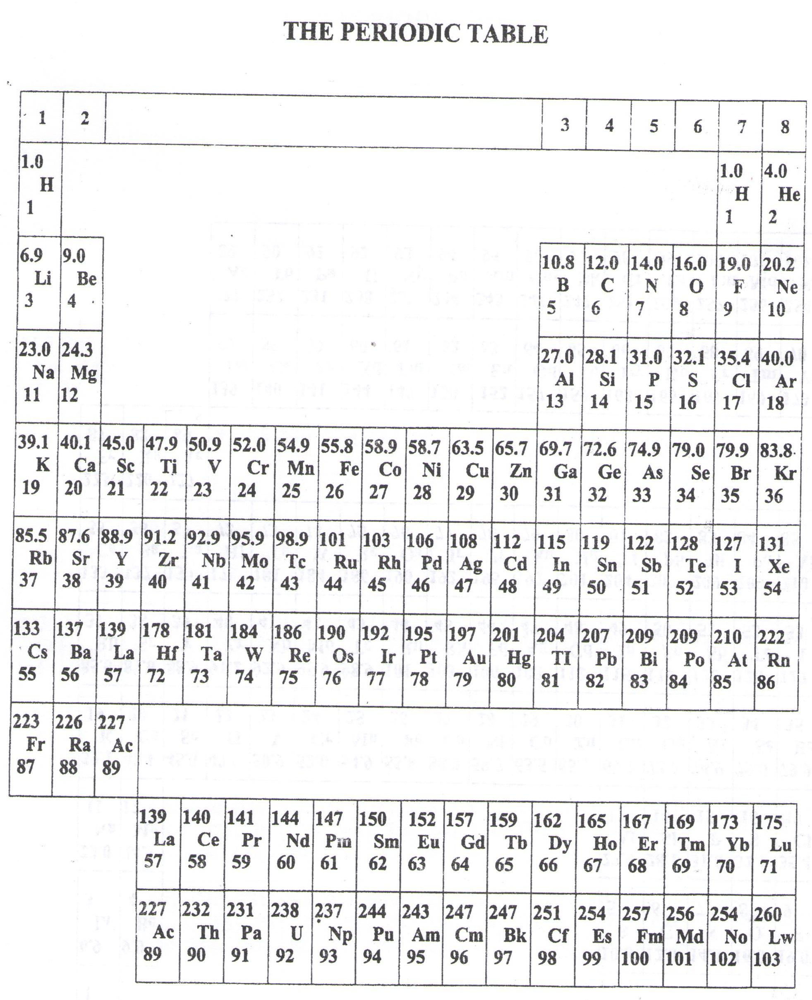

* ===END===

WELCOME TO SENIOR SIX, YEAR 2023

This is the last page of the printed paper, Page 05